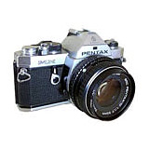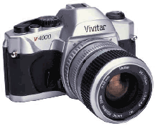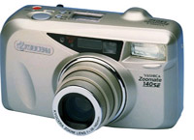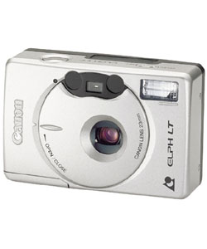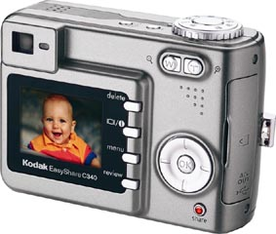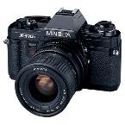

**We Don’t use…Point and shoot camera’s or digital**

**Camera(s) to use…**

**35mm Manual Film**

**Cameras**

Recommended cameras:

**Pentax K-1000**

**Canon AE-1**

**Canon Rebel**

Places to find them:

-Your family- Grandparents, Aunts/Uncles,

Neighbors- **Usually for free!**

-Ebay- Search “35mm manual camera”

**Make sure seller has a good rating and**

**has a return policy**.

Tempe Camera- More $$, but the camera

will be re-furbished.

Average cost: Free – up to $50.